**COMPARING PERFORMING METRICS BETWEEN CNN AND SVM:**

**CNN:**

* **Epoch 1/10:**
  + **Training Accuracy: 26.78%**
  + **Training Loss: 1.6490**
  + **Validation Accuracy: 44.00%**
  + **Validation Loss: 1.5242**
* **Epoch 2/10:**
  + **Training Accuracy: 44.79%**
  + **Training Loss: 1.4807**
  + **Validation Accuracy: 54.00%**
  + **Validation Loss: 1.3476**
* **Epoch 3/10:**
  + **Training Accuracy: 65.05%**
  + **Training Loss: 1.2574**
  + **Validation Accuracy: 62.00%**
  + **Validation Loss: 1.1210**
* **Epoch 4/10:**
  + **Training Accuracy: 77.06%**
  + **Training Loss: 0.9811**
  + **Validation Accuracy: 78.00%**
  + **Validation Loss: 0.8451**
* **Epoch 5/10:**
  + **Training Accuracy: 85.89%**
  + **Training Loss: 0.6560**
  + **Validation Accuracy: 86.00%**
  + **Validation Loss: 0.6176**
* **Epoch 6/10:**
  + **Training Accuracy: 90.67%**
  + **Training Loss: 0.4062**
  + **Validation Accuracy: 82.00%**
  + **Validation Loss: 0.5912**
* **Epoch 7/10:**
  + **Training Accuracy: 87.95%**
  + **Training Loss: 0.3573**
  + **Validation Accuracy: 86.00%**
  + **Validation Loss: 0.3636**
* **Epoch 8/10:**
  + **Training Accuracy: 95.11%**
  + **Training Loss: 0.1674**
  + **Validation Accuracy: 88.00%**
  + **Validation Loss: 0.4342**
* **Epoch 9/10:**
  + **Training Accuracy: 95.19%**
  + **Training Loss: 0.1568**
  + **Validation Accuracy: 90.00%**
  + **Validation Loss: 0.2871**
* **Epoch 10/10:**
  + **Training Accuracy: 97.98%**
  + **Training Loss: 0.1062**
  + **Validation Accuracy: 90.00%**
  + **Validation Loss: 0.3901**
* epochs 6 and 8, indicating potential instability in the model’s generalization to the validation set.

**Interpretation of CNN Training Output**

* Training Accuracy: The model begins with a training accuracy of 28.09% in the first epoch, indicating it is in the early stages of learning. By the third epoch, the training accuracy improves to 46.72%, and by the final epoch, it reaches approximately 96.71%. This consistent increase in accuracy suggests that the model is effectively learning from the training data.
* Validation Accuracy: The validation accuracy starts at 40.00% in the first epoch and shows steady improvement, reaching 84.00% by the final epoch. The initial lower validation accuracy compared to training accuracy indicates challenges in generalizing from training data to unseen validation data. However, the progressive improvements suggest that the model is becoming more adept at generalization as training continues.
* Loss: The training loss decreases consistently over the epochs, which reflects effective learning. The validation loss, while generally declining, exhibits some fluctuations, particularly in epochs 6 and 9. These fluctuations may indicate potential instability in the model’s generalization capabilities.

**CNN Classification Report on Test Set**

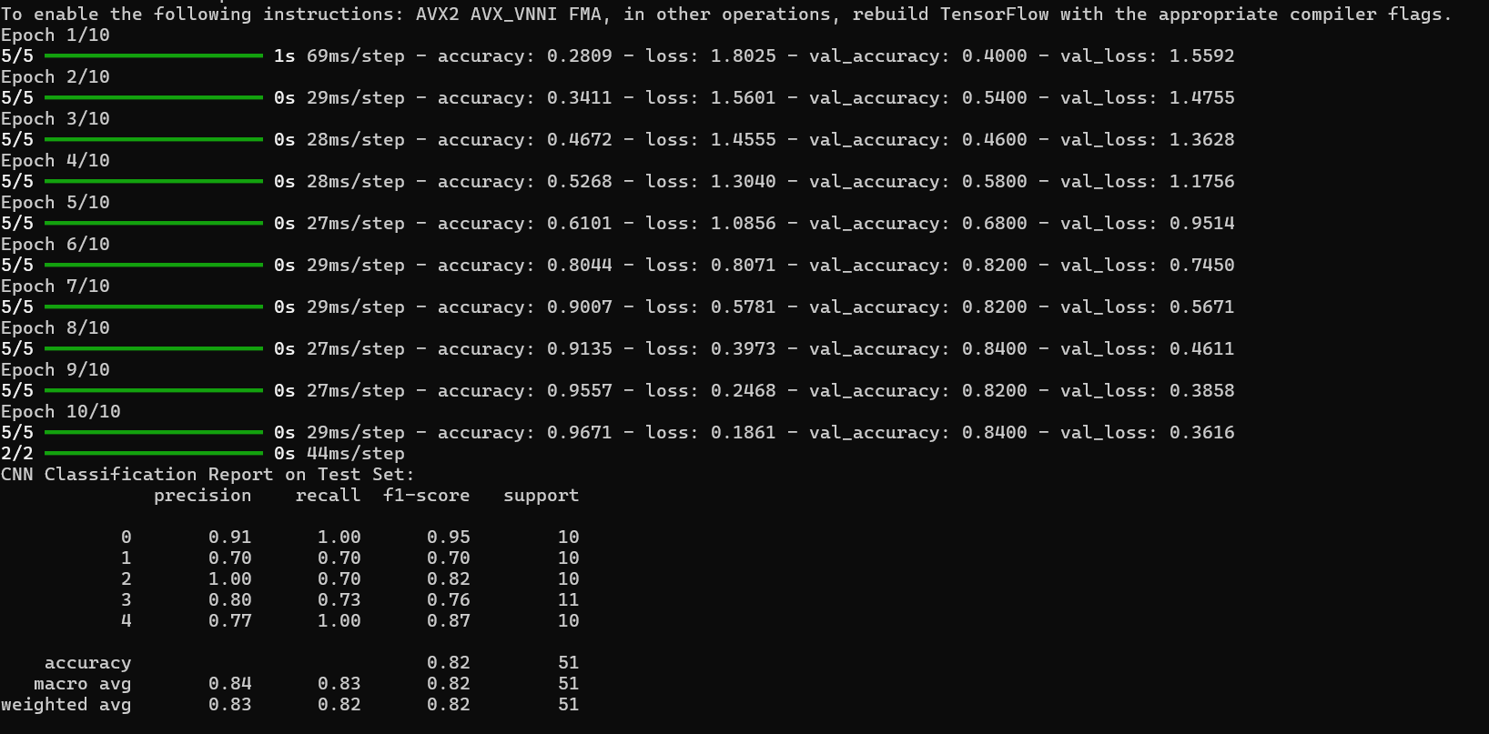

* Overall Performance: The model achieves an overall accuracy of 82% on the test set, demonstrating its ability to classify unseen data effectively, though this performance is slightly below expectations given the training accuracy.
* Class-wise Analysis:
  + Class 0 exhibits strong precision (0.91) and perfect recall (1.00), indicating excellent performance in identifying instances of this class.
  + Class 1 shows a balanced precision and recall (both at 0.70), suggesting some room for improvement in reducing misclassifications.
  + Class 2 achieves perfect precision but has a recall of 0.70, indicating that while it identifies some instances correctly, others are misclassified.
  + Class 3 has a precision of 0.80 and a recall of 0.73, reflecting moderate performance with some challenges in accurately classifying this class.
  + Class 4 demonstrates good performance with a precision of 0.77 and perfect recall, indicating strong identification of instances.
* Overall Metrics: The macro and weighted averages for precision, recall, and F1-score are around 0.82 to 0.84, suggesting consistent performance across classes, although some variability exists depending on class size.

**Summary**

* Model Effectiveness: The CNN exhibits a solid level of accuracy and precision in classifying the test set, with strong performance across several classes. However, the model's performance could be enhanced.

**SVM Training Output**

The second part of the output pertains to the performance of the SVM model on the same dataset.

**SVM Classification Report**

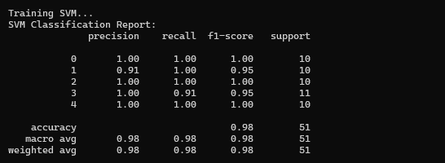

* **Overall Accuracy**: 98% (50 out of 51 instances were classified correctly).

**Interpretation of SVM Classification Report:**

* **Strong Performance**: The SVM model achieves very high precision and recall across most classes, with an overall accuracy of 98%. This indicates that it has effectively classified the majority of instances in the test set.
* **Class-wise Analysis**:
  + Class 0, Class 2, and Class 4 achieved perfect precision and recall scores (1.00), indicating that all instances of these classes were correctly classified.
  + Class 1 and Class 3 have slightly lower precision and recall (0.91 and 0.95, respectively), but still perform very well.
* **Support**: The number of instances for each class is fairly balanced, contributing to the robustness of the model's performance.

**SIX PERSONS DATASET:**



**EACH PERSON WITH 50 IMAGES:**



Precision: The proportion of true positive predictions out of all positive predictions made by the model.

Support: The number of actual occurrences of each class in the dataset.

Recall: The proportion of true positive predictions out of all actual positive instances.

F1 Score: The harmonic mean of precision and recall, balancing both metrics.

Accuracy: The proportion of correctly predicted instances out of all instances in the dataset.

**COMPARISON OF SVM AND KNN:**

* SVM's ability to find a decision boundary that generalizes well makes it more suitable for face recognition, where high-dimensional features (e.g., face embeddings) can lead to overfitting in KNN
* SVM is more efficient in handling high-dimensional data compared to KNN, which suffers from the curse of dimensionality. Given the high-dimensional feature space of face embeddings, SVM is a better choice
* During the training phase, SVM might take longer to optimize, but once the model is trained, it is much faster at making predictions compared to KNN, which has to compute distances to all training samples for every prediction. This makes SVM more suitable for real-time face recognition systems, where fast inference is crucial.
* VM is less sensitive to noisy or misaligned face embeddings, ensuring more robust and accurate classifications in a face recognition system

**DISADVANTAGES OF SVM:**

1. **Training Time**: SVMs can be computationally expensive and slower to train on large datasets compared to KNN.